Lab#09

**Objective**: To work with MVC architecture for Enterprise level application.

**Task#1:**Create a simple Login and Registration page in which user can register and login via database.

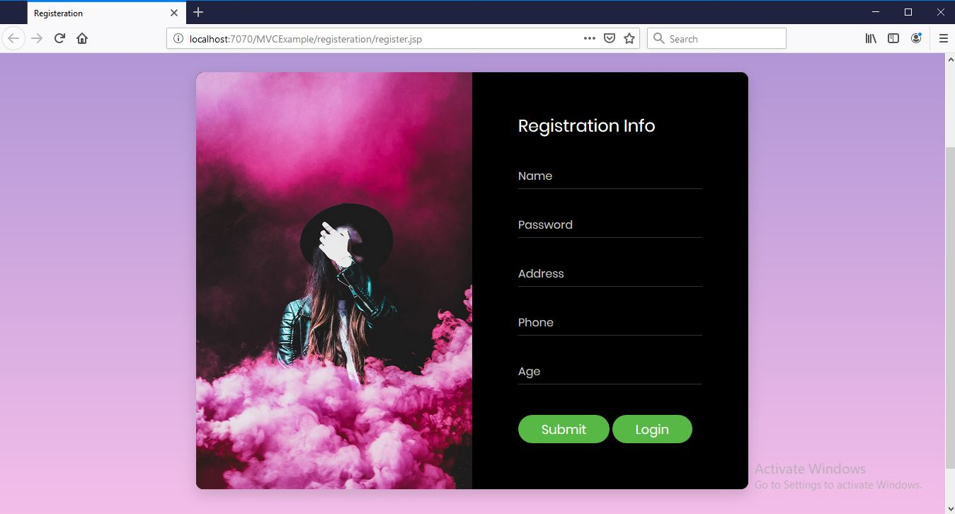

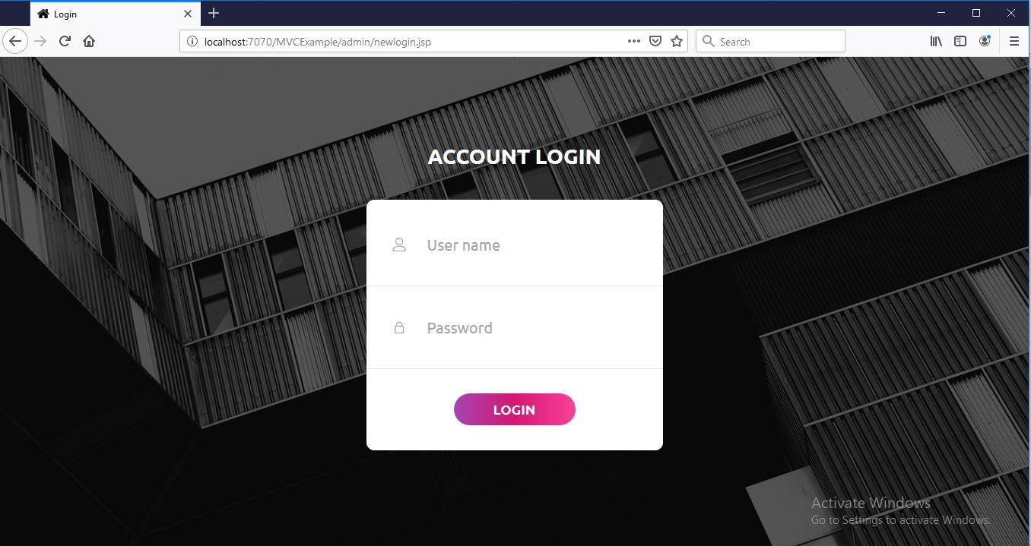

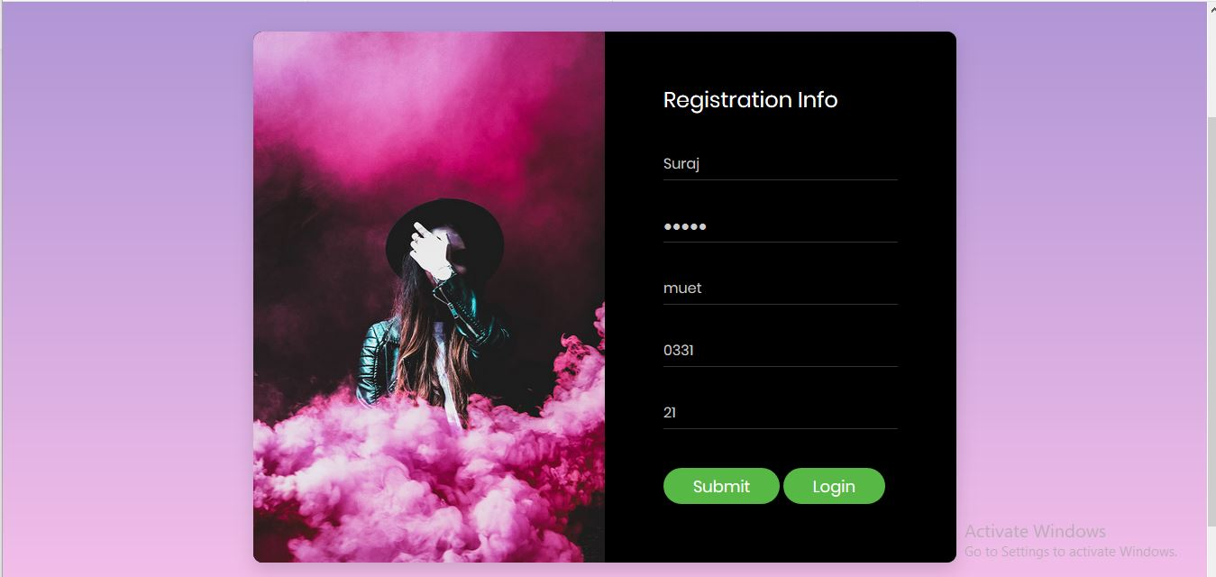

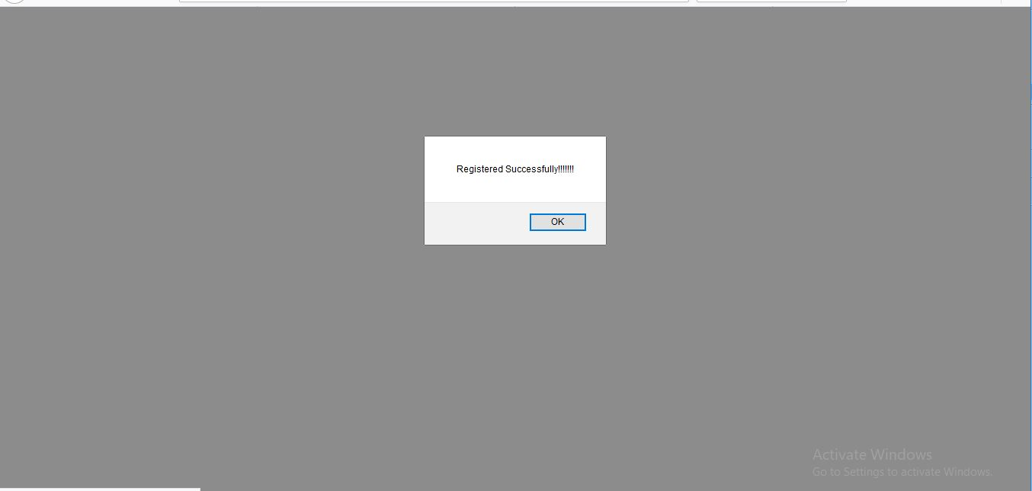

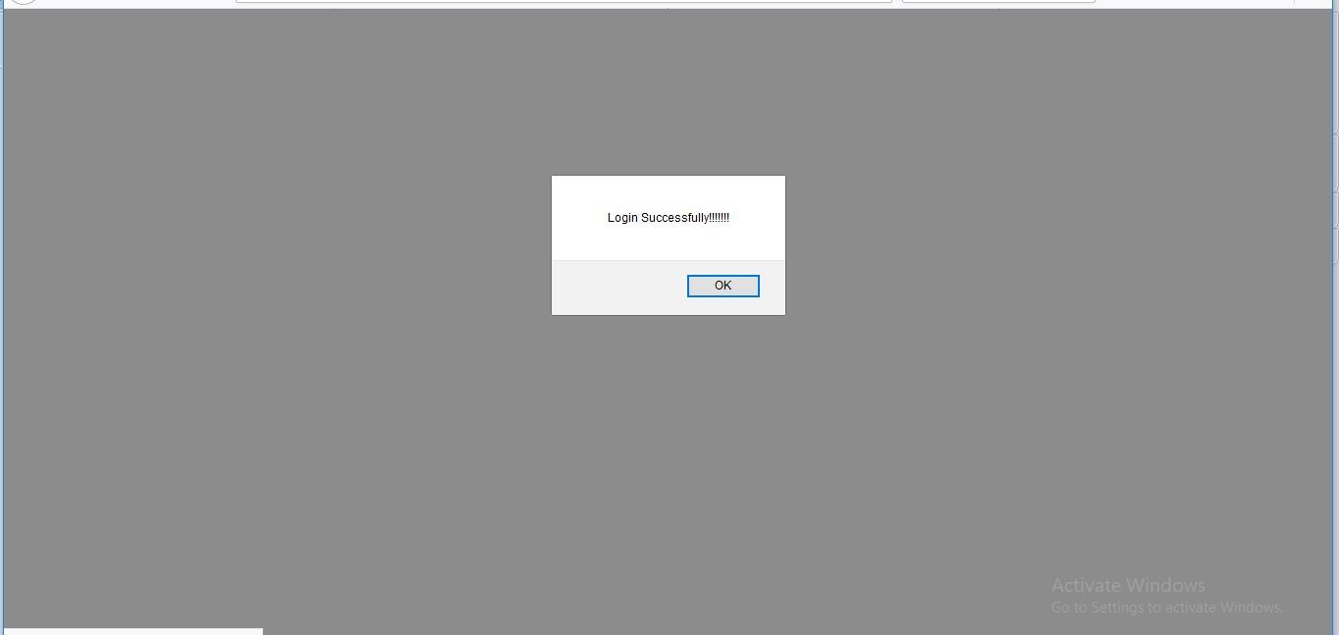

**Task#2:**Create a simple Curd application.

**DELETE Operation:**

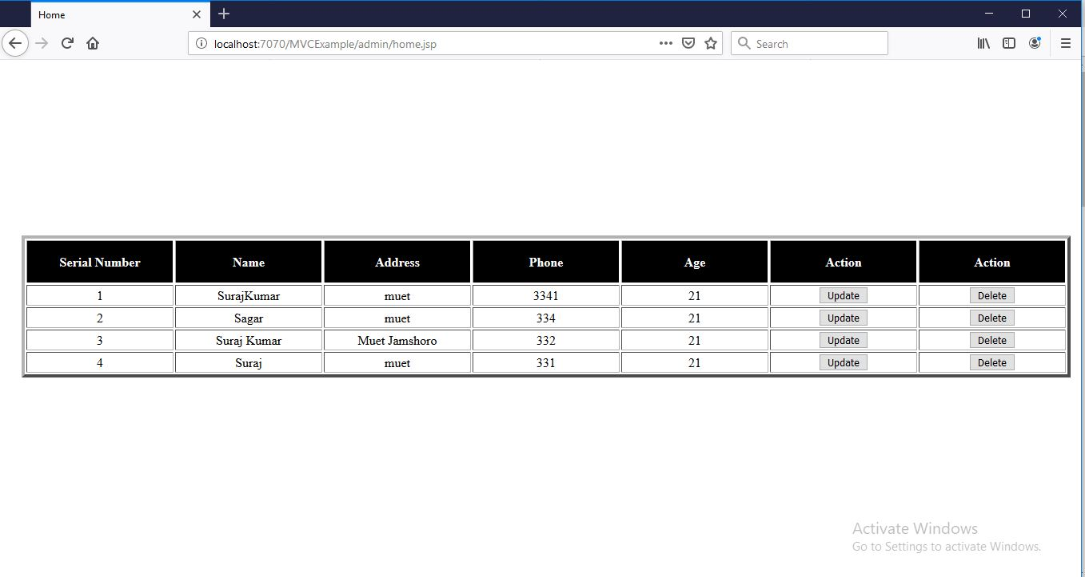

**Serial Number 2,3,4 Deleted.**

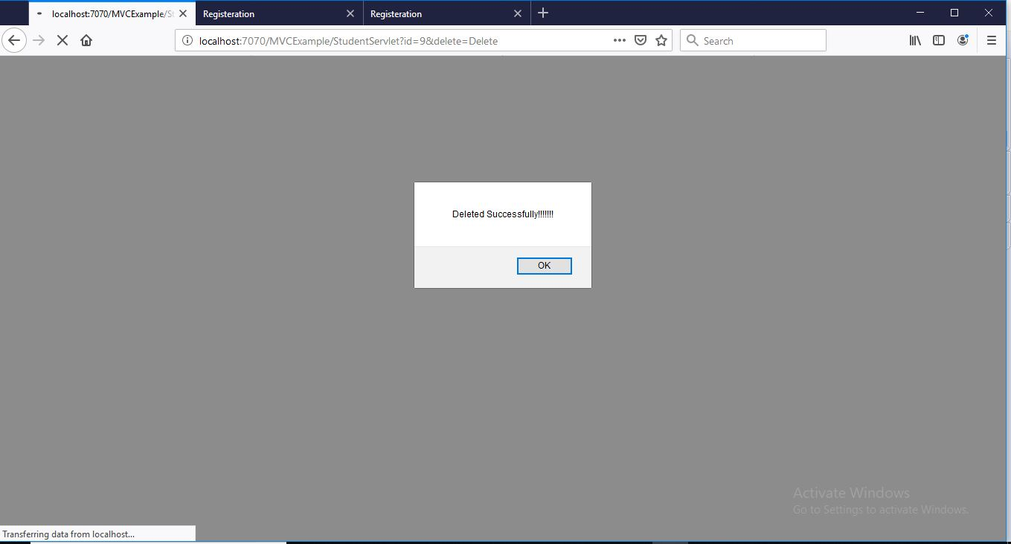

**Update Operation:**

**Serial Number After Update**

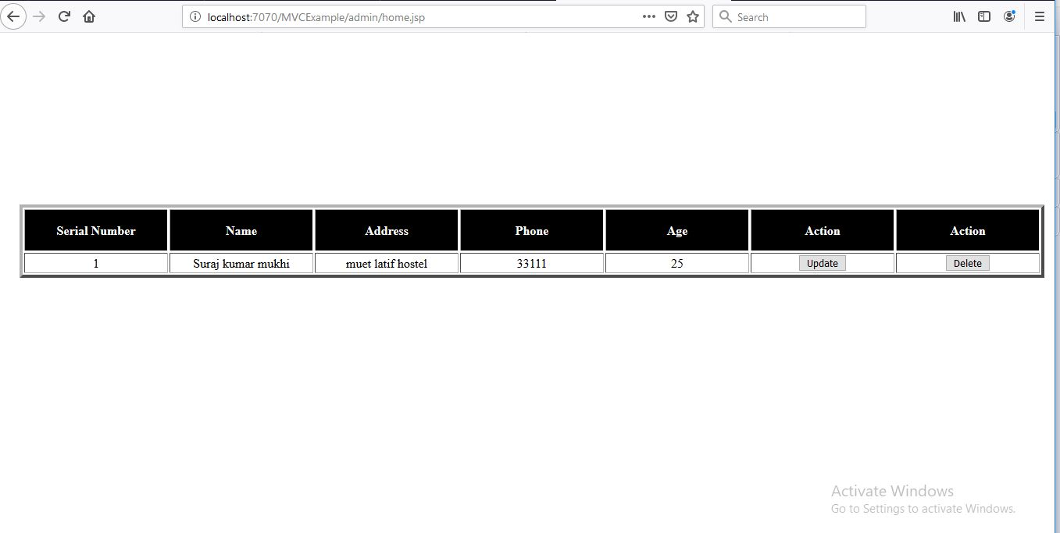

**Update Alert.**

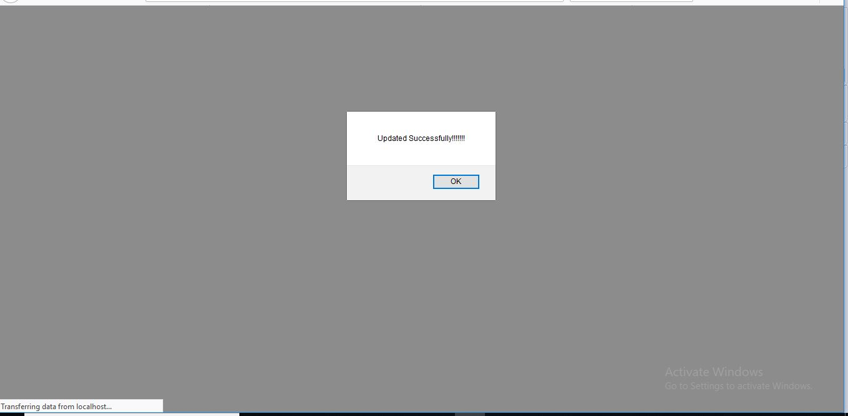

**Project Directory: MVC**

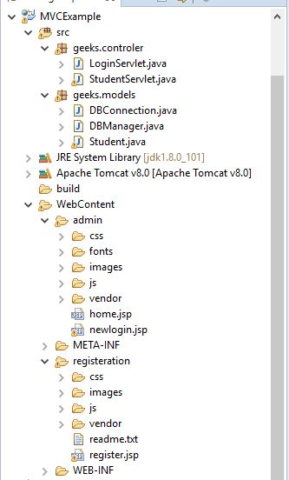

**DataBase:**

